Photo Critique Form

Name:_________________________________________________________________ Date:______________________

Photo by:_______________________________________________________________ Period:_____________________

Exchange photos with another student in your class. Refer to the information on the back of this sheet and critique the photo using terms specific to photography. Be professional when you critique another’s work, do not insult or degrade the photographer. This should be an unbiased and honest evaluation of the photo. Be sure to provide evidence of your findings in your critique. Note: This form is formatted to make it easy to read. Please do not change font or spacing.

- What kind of Grain does the picture have?  - Does it have Fine Grain? Looks almost digital  - Does it have Coarse Grain? Looks pixelated |  | 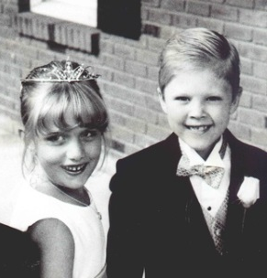
 | Fine Grain | Coarse Grain
- What kind of Tonal Contrast is in the picture?  - High contrast, mainly pure blacks and pure whites with little gray tones  - Normal contrast, equal amounts of pure blacks, pure whites and gray tones  - Low contrast, more gray tones with little pure blacks or pure whites | 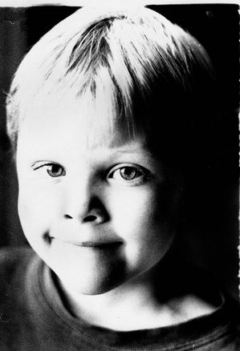
 | High Contrast | Normal Contrast | Low Contrast
- Does the picture contain Shape?
  - Picture looks 2D, like a line or silhouette

- Does the picture contain Form?
  - Picture looks 3D, shadows in picture give it depth
 | Shape | Form
- Does the picture contain Texture?
  - Picture looks as though you could feel it with your hand.

 | Texture
- What kind of Depth of Field is in the picture?  - Depth of Field, the entire picture is in focus  - Shallow Depth of Field, the subject is in focus but the background is not. | 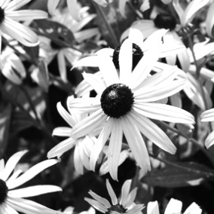 | 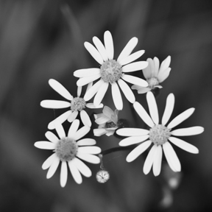
 | Depth of Field | Shallow Depth of Field
- What Composition technique was used? | List composition technique and explain if the photo matches the composition technique.

